Betty Bryer
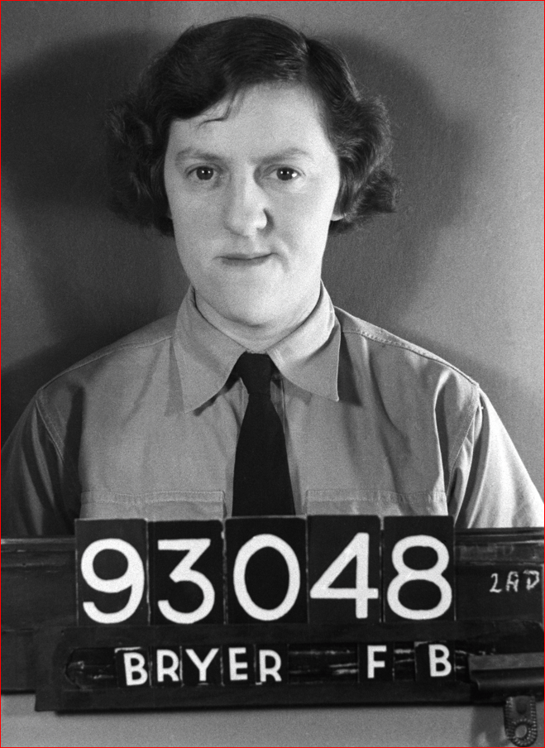
Florence Betty Bryer
Service Number 93048
Betty was born to Walter and Elizabeth Bryer on 28 Mar 1917. Walter and Elizabeth had emigrated to Australia in 1912 with their 2 older children Frank and Daisy. Betty and a younger brother Walter were born in Cowra.
After working and living on several farms around the district including “Hillcrest’ for Arch McColl, the Bryers became share farmers on Gambarra Station When Gambarra was subdivided for Soldiers Settlement, Mr R.K.Dempsey (owner of Gambarra Station) insisted that the former sharefarmers were also given the chance to purchase a block. The Bryers were able to purchase a block upon which was the overseer's house which became “Sunnybrae’. “Sunnybrae” remains in the Bryer family still.
Betty attended Greenethorpe School and went on to become a seamstress. In February 1942 at the age of 24, Betty enrolled in the Women’s Australian Auxiliary Air Force in Wolloomooloo. She served for 3 years and 9 months driving both cars and trucks in Australia. During this time Betty became a Corporal. She was discharged in November 1945.
Betty returned to “Sunnybrae” where she lived with her sister Daisy until the early 1970’s when they moved into Cowra. Betty married later in life to Hugh Edge.
Below are cartoons drawn by Lola who was in Betty’s unit. These were enclosed in letters written by Lola to Betty.
(Photo of Betty Bryer from the Collection of the National Archives of Australia)

